Ideation Phase
Define the Problem Statements

Date | 29 September 2026
Team ID | SWTID-2026-9474
Project Name | StudyBuddy
Maximum Marks | 2 Marks

Customer Problem Statement:
As a student, I want to understand difficult subjects, clear my doubts quickly, and prepare effectively for exams, but I often struggle to find simple explanations and personalized study guidance. I may not always have access to teachers or study materials when I need help, and creating a proper study plan can also be difficult. I need a single platform that can provide instant answers, explain concepts in an easy way, generate practice quizzes, suggest personalized study plans, and track my learning progress. Without such support, I may feel confused, stressed, and less confident about my studies and academic performance.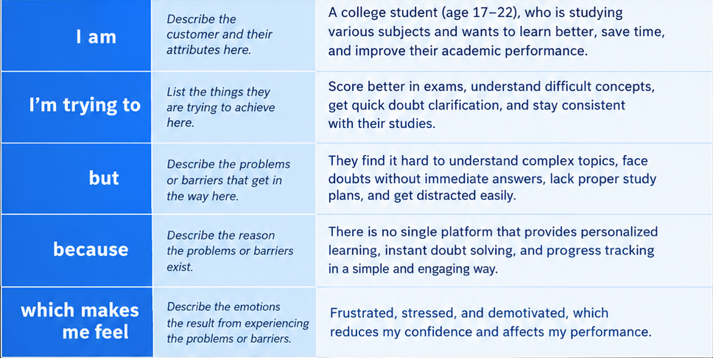
Example:
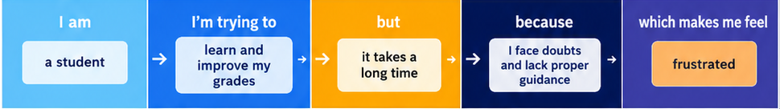
Problem Statement (PS) | I am (Customer) | I’m trying to | But | Because | Which makes me feel
PS-1 | Student | Learn and score better | Takes a lot of time | Doubts & no personal guidance | Frustrated & stressed
PS-2 | Student | Understand difficult topics | Finds it hard to get help | No single platform for all needs | Confused & demotivated

